# Gradient Descent

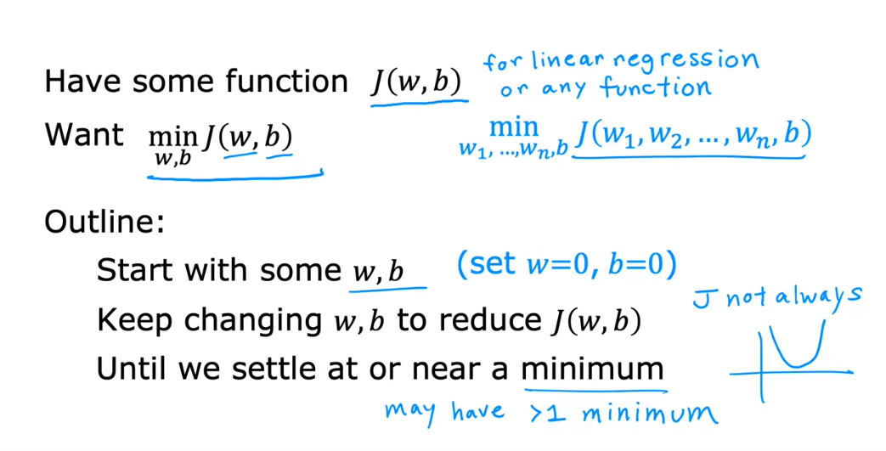

Not always a hammock or bow

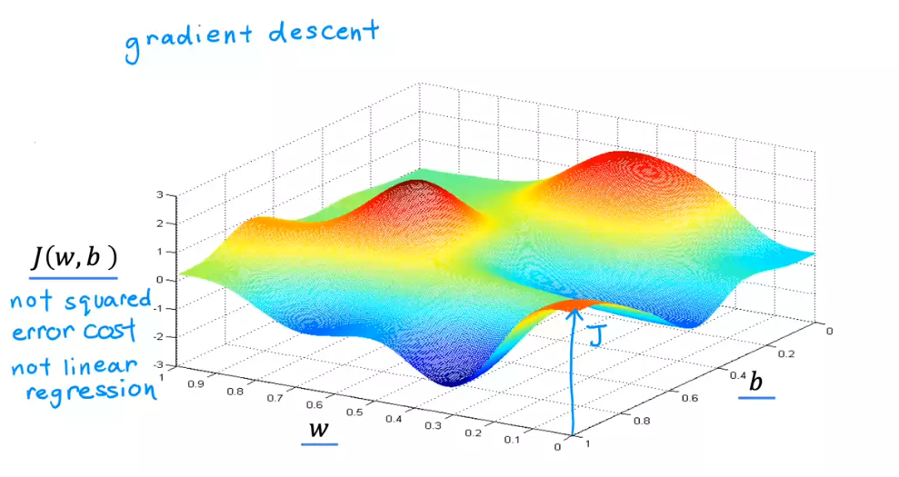

Like hills

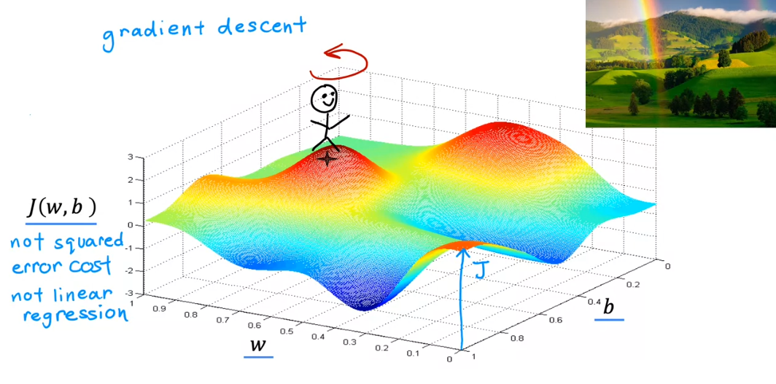

Goal: go downhill to get to the minimum point!

spin around and check which direction you will get to the steepest descent faster, and take a baby step for that!

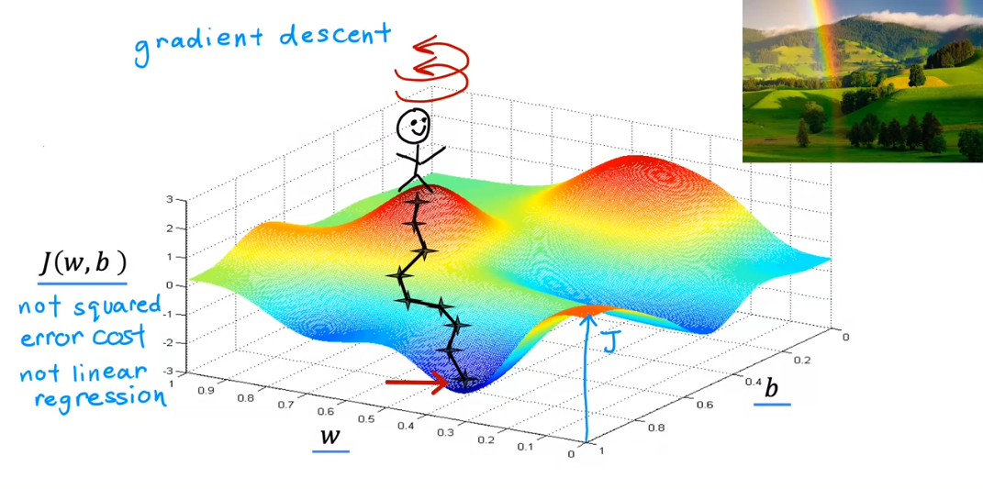

* Choosing a starting point for w and b

Try choosing a different starting point:

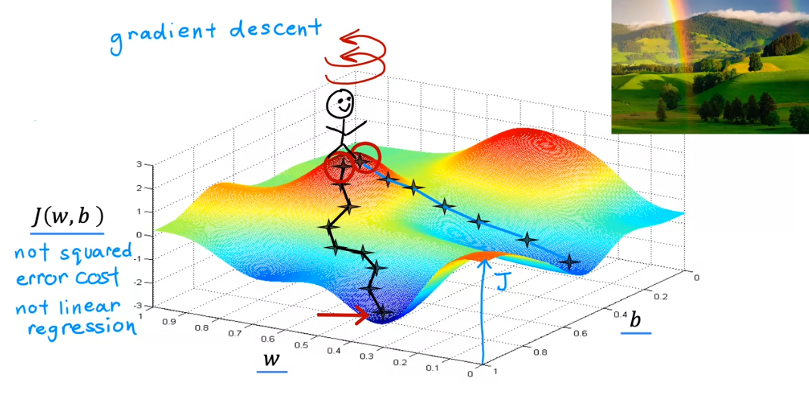

spin around and check which direction you will get to the steepest descent faster, and take a baby step for that!

* This will lead you to another descent apart from the first one!

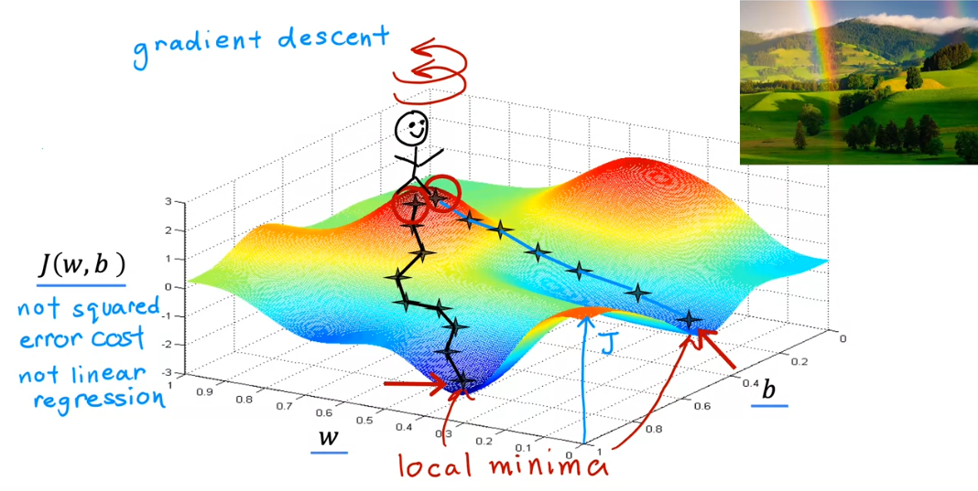

# Implementing Gradient Descent

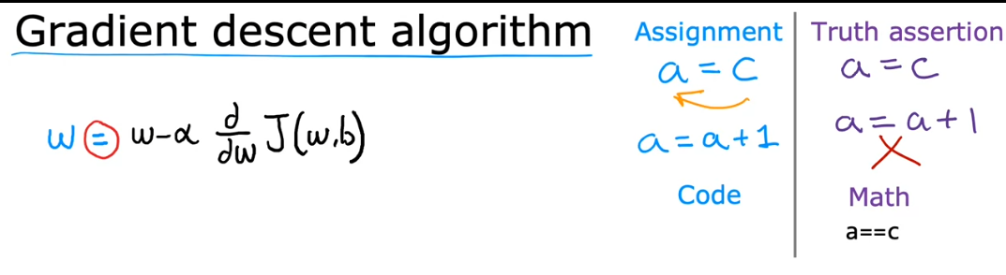

* Assignment operator!

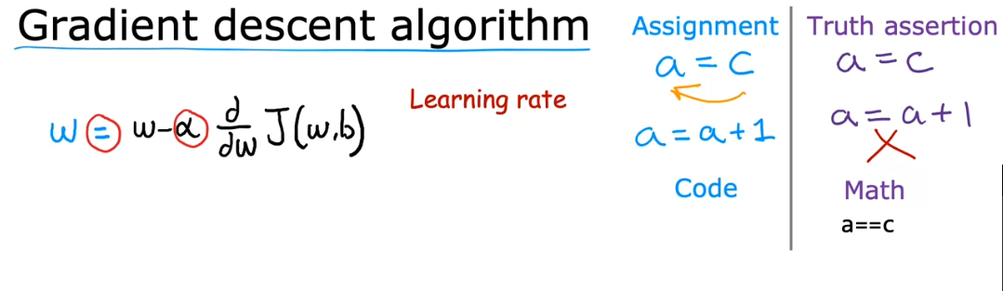

Learning rate

* Between 0 and 1
* How big of a step you take downhill

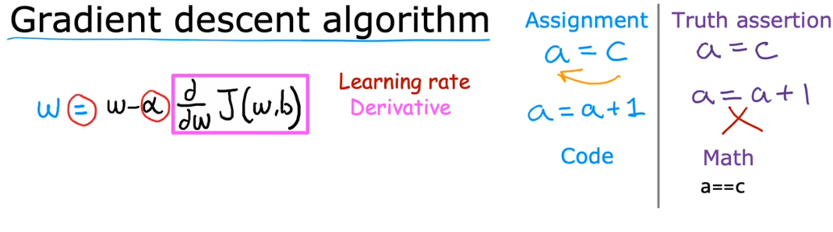

* Which direction you want to take your baby step

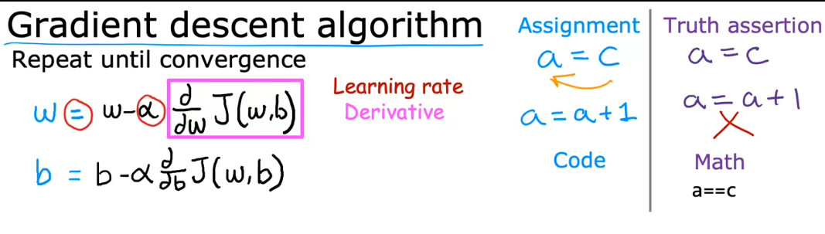

* Convergence: reach the point at a local minimum where the parameters w and b no longer change much with each additional step you take

Important detail:

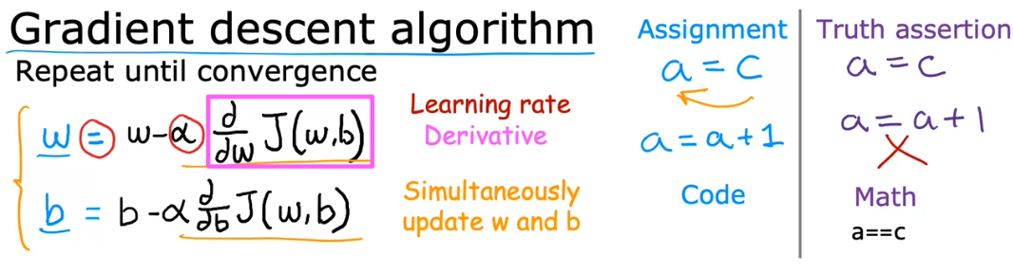

* Simultaneously update w and b!!

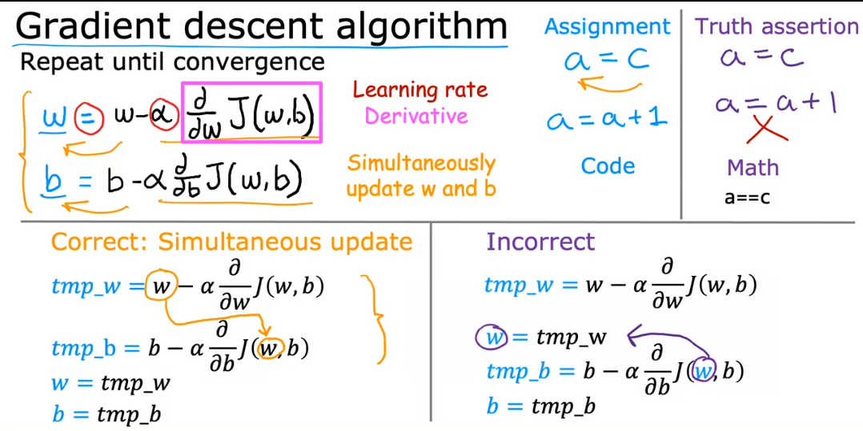

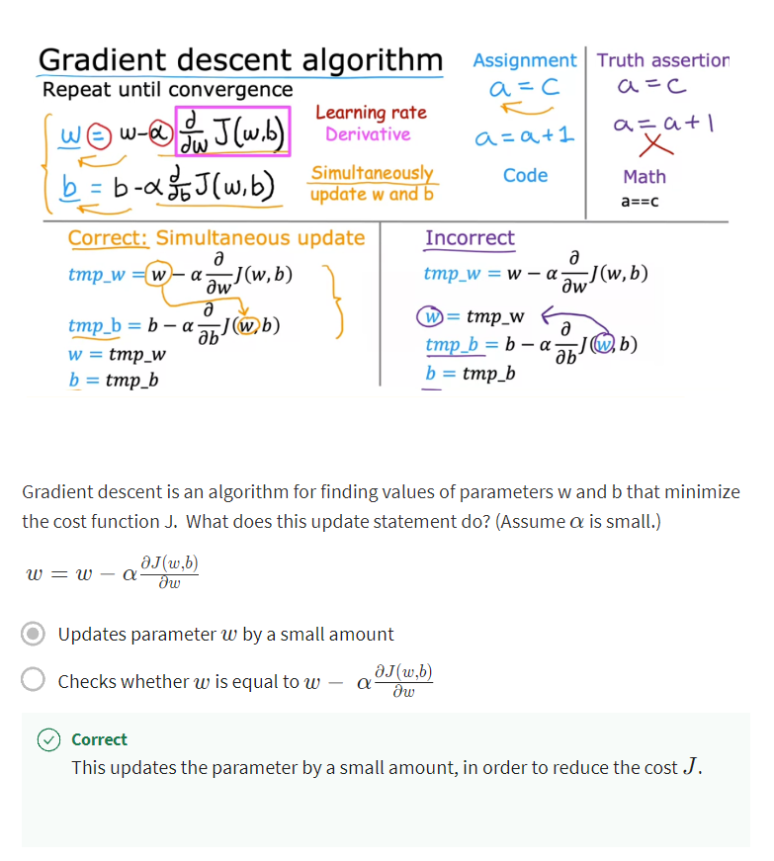

# Gradient Descent Intuition

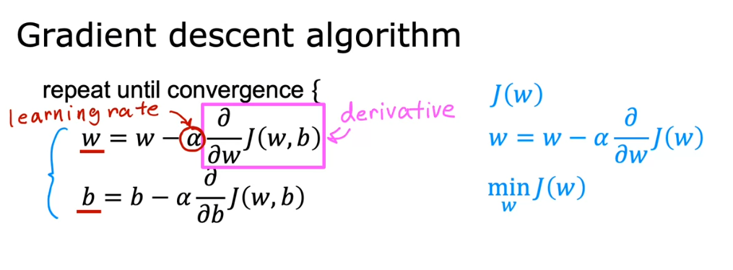

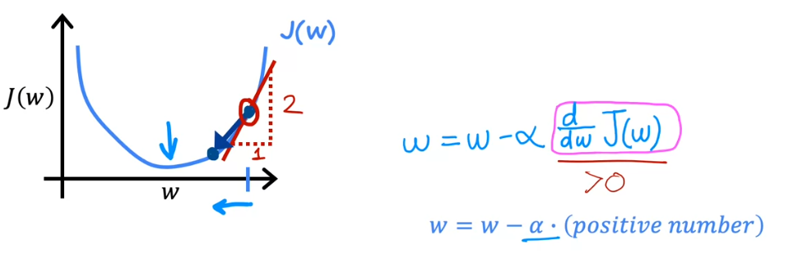

* Learning rate (alpha) always positive
* Using this example, w – positive number, w is decreasing (going to the left)
* This is going to the right direction to reach the minimum w

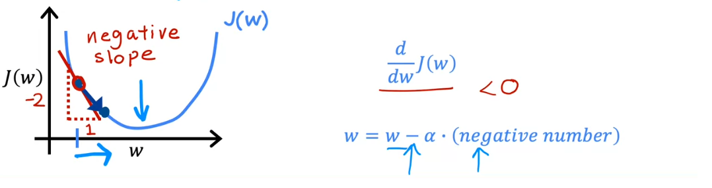

* Using this example, w – negative number, w is increasing (going to the right)
* This is also going to the right direction to reach the minimum w

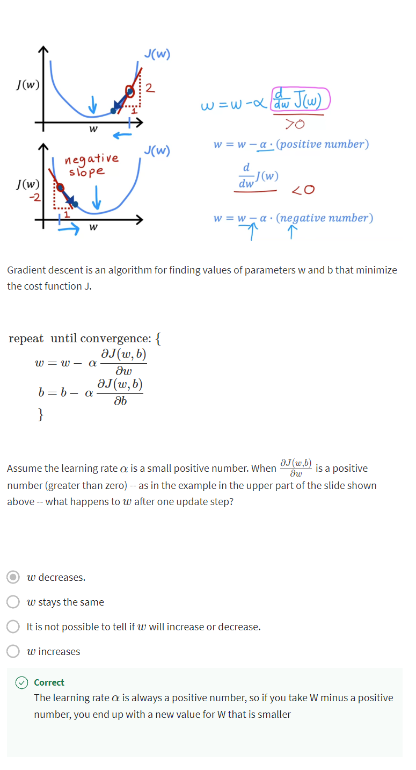

# Learning Rate

* Choice of learning rate will have a big impact of your gradient descent

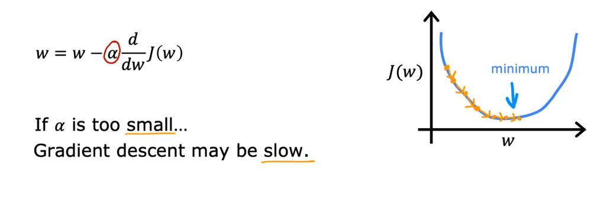

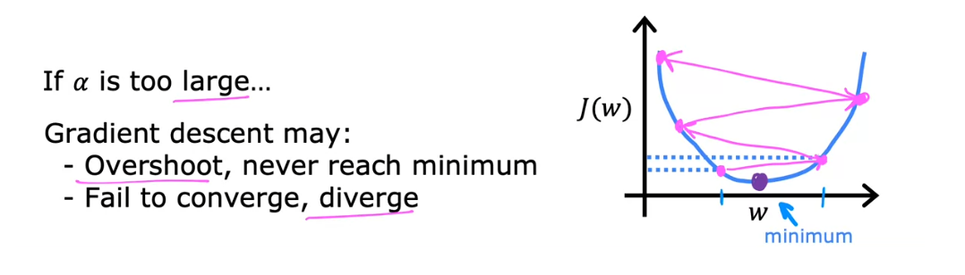

If you already reached a minimum:

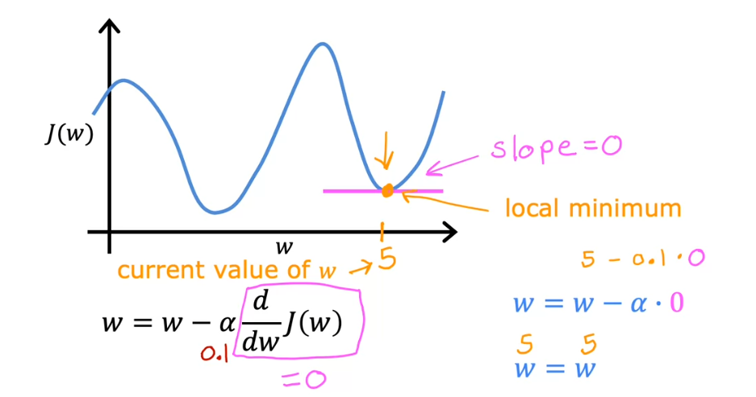

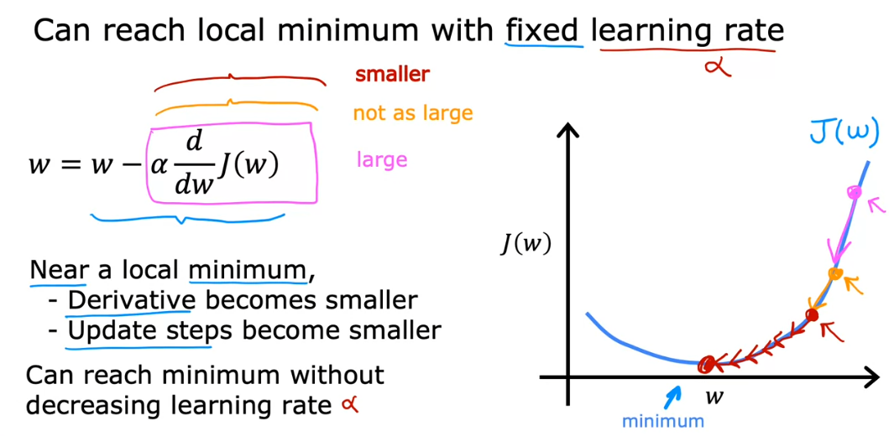

* It is better that the slope is the one that is changing
* That is why we can reach a local minimum even with fixed learning rate

# Gradient Descent for Linear Regression

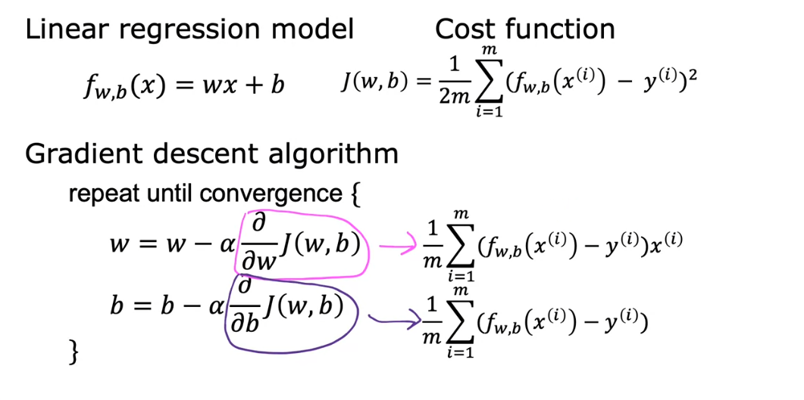

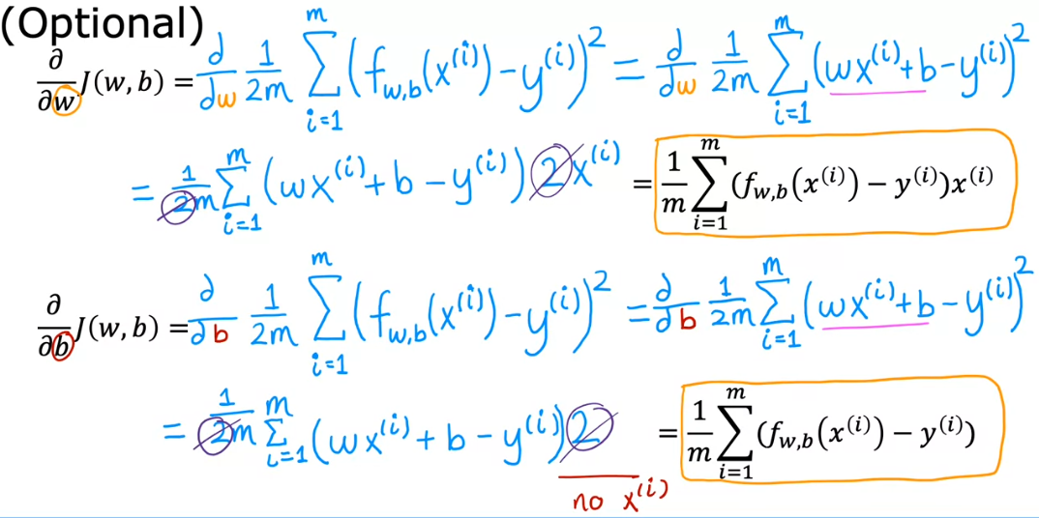

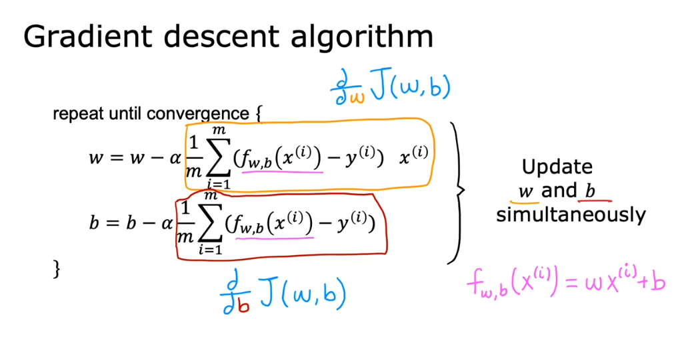

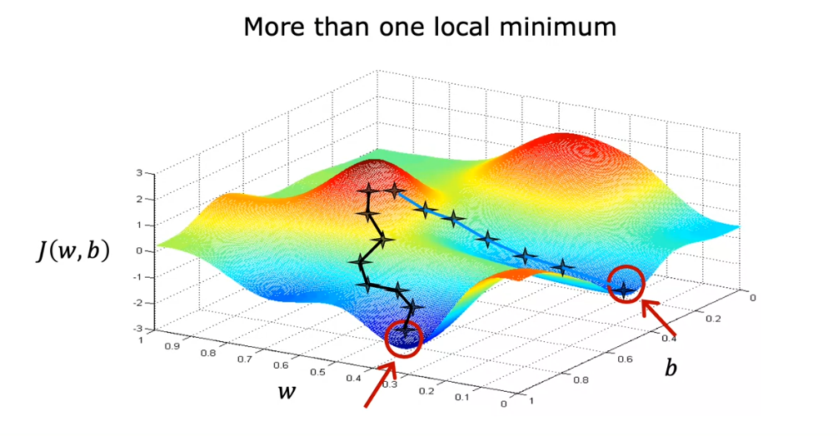

When using with squared error cost function

* Only 1 minimum, no need to worry other minimum

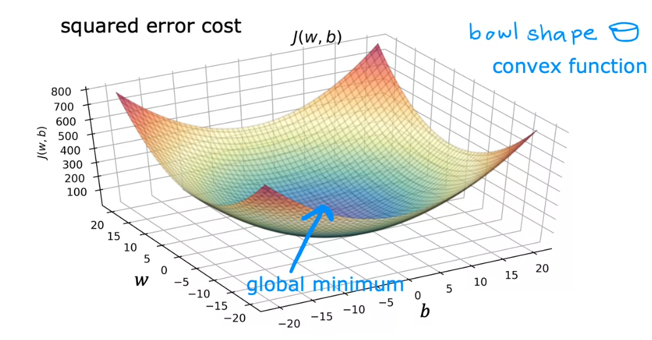

# Running Gradient Descent

Our initial w and b

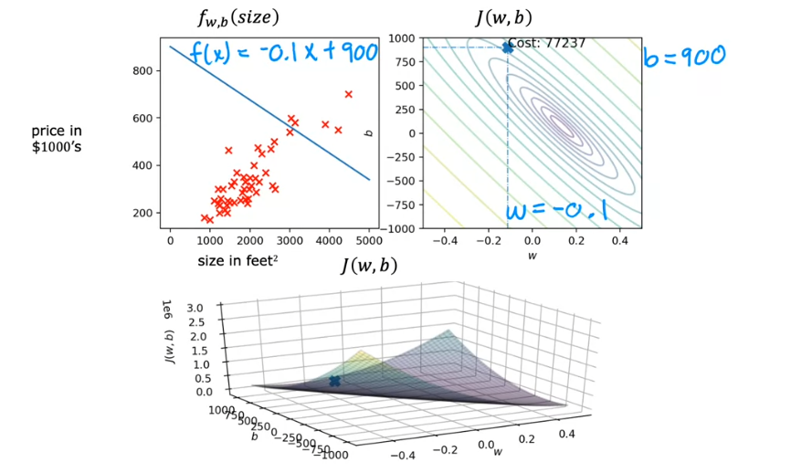

Adding step

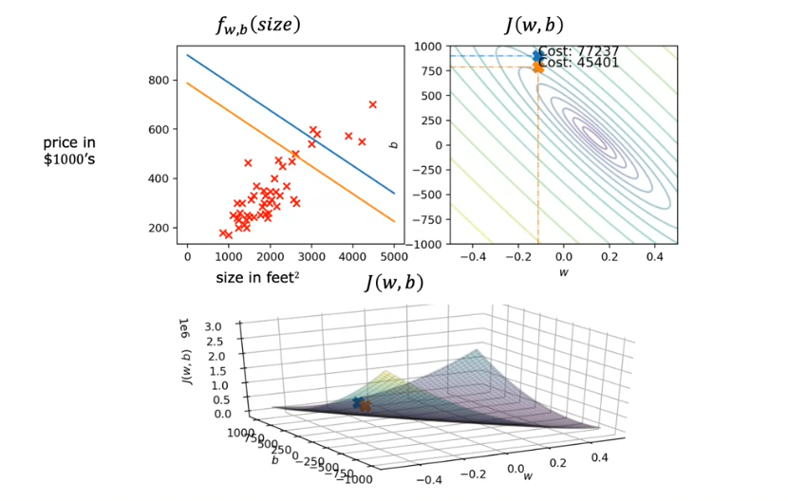

Adding more steps until we reach the global minimum

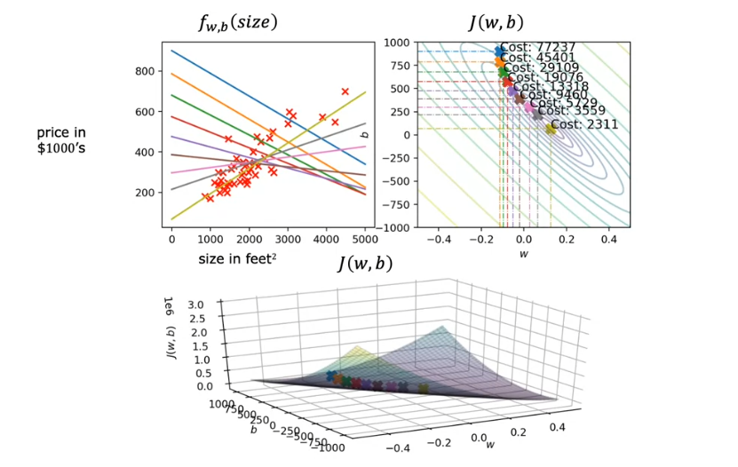

## Batch Gradient Descent

